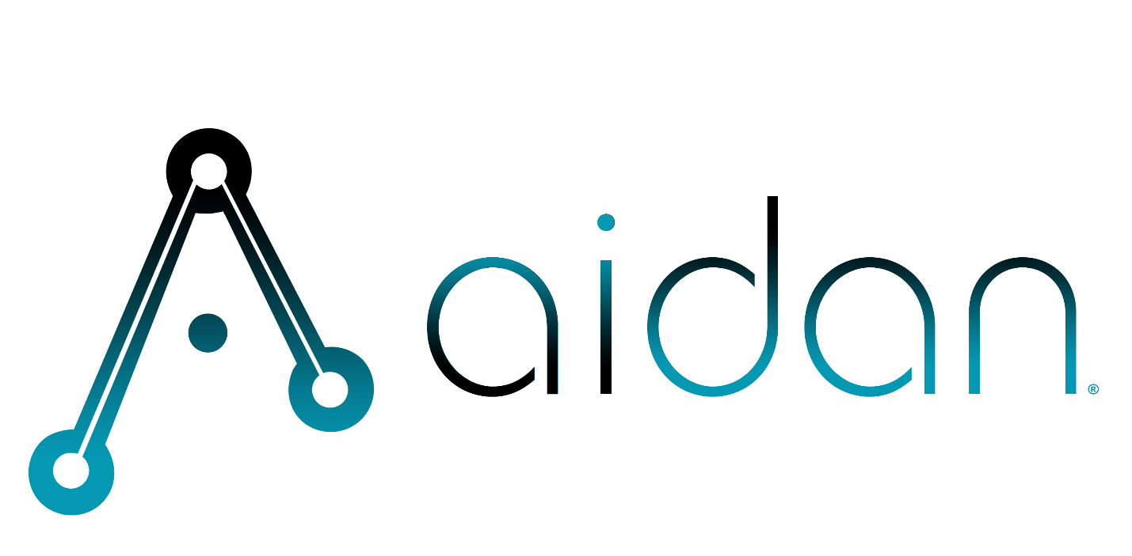

HC

statement of work
Gent Machine – machine maintenance
Aidan Systems
September 23th, 2025
Contents
1. objectives 2
2. project requirements 2
3. engagement approach 3
4. scope of services 4
4.1. business process scope 4
4.2. organization scope 4
4.3. location scope 5
4.4. application scope 5
4.5. data scope 5
4.6. technology scope 5
5. project timeline 6
6. budget, fees and expenses 8
6.1. invoicing & payment terms 8
7. assumptions 8
8. signatures 9

objectives

MAGNET is interested in executing an 8–10 week pilot at Gent Machine to capture and operationalize expert maintenance knowledge for Davenport machines, and to provide a shop-floor web application that uses Retrieval-Augmented Generation (RAG) to assist maintenance personnel with troubleshooting, setup, and preventive maintenance.

Objectives:
- Preserve critical technician knowledge through structured interviews and continuous capture.
- Reduce unplanned downtime and accelerate troubleshooting on Davenport machines.
- Improve onboarding and standardize maintenance procedures.
- Validate a pragmatic, low-risk, text-first approach that delivers measurable value before expansion.

Reference content for the system will initially include:
- Equipment manuals, procedures, and parts lists (PDFs and text)
- Transcripts from expert interviews (audio → text)
- Internally developed setup instructions and troubleshooting steps
- Select OEM FAQs and related text-based knowledge

project requirements

Target Equipment and Scenarios:
- Davenport machines — focus on top-5 issues prioritized by Gent.
- Primary user group — Gent maintenance personnel and relevant operators.
Functional Requirements:
- Web-based chatbot terminal accessible from the shop floor.
- Users ask questions and receive step-by-step, source-cited guidance.
- Responses reference the exact passages used; users can open cited sources.
- Support multi-turn follow-ups to refine or continue guidance.
Knowledge Capture Requirements:
- Onsite structured interviews with selected expert(s) (1-2 hours per expert).
- Audio transcription using Azure Content Understanding
- Manual review and structuring of transcripts before indexing
Security and Access Requirements:
- Basic Azure AD authentication for internal users (pilot scope).
- Encrypted data at rest and in transit; secrets in Azure Key Vault.
Non-Functional Requirements (pilot targets):
- Response time: under 10 seconds for 90% of queries (pilot-scale target).
- Basic reliability appropriate for a pilot; limited monitoring and audit logging (add-on).

engagement approach

To implement this pilot, Aidan Systems (as subcontractor to MAGNET) will build a text-first RAG solution on Microsoft Azure. The pilot will use an Azure AI Foundry workspace with Azure OpenAI for LLM, Azure Cognitive Search for vector retrieval, Azure Blob for storage, Azure Content Understanding for transcription, and Azure Key Vault for secrets.
Aidan will host the pilot in its Azure environment for speed, with the option to transfer the solution to MAGNET or Gent’s tenant in a subsequent phase.
The engagement emphasizes:
- Rapid knowledge capture from a departing/retiring technician focused on Davenport machines.
- Pragmatic scoping: text-first (manuals, transcripts, parts lists) to prove value quickly.
- Iterative delivery of the chatbot terminal with testing.

scope of services
The scope of this statement of work can be defined most clearly by breaking it into specific categories.
There are three domains related to business scope:
- Business Process Scope describes the work activities.
- Organization Scope describes the people, teams, and departments.
- Location Scope describes the physical locations or facilities.
There are three domains related to the technical scope:
- Application Scope describes specific business software applications.
- Data Scope describes the specific data items, structures, relationships, and business rules for information.
- Technology Scope describes the hardware, system software, communication components, and development tools.
The following scope definitions, Section 4.1-4.6, define the areas that are in and out of scope. Any areas not specifically identified as “in scope” are assumed to be “out of scope”. Specific items listed as “out of scope” are presented for clarity only.

business process scope
In Scope
- Plan and conduct expert interviews; record, transcribe, and curate content.
- Build the initial knowledge base for Davenport top-5 issues.
- Implement RAG over text artifacts; tune prompts and retrieval.
- Deliver a browser-based shop-floor chatbot terminal.
- Conduct pilot testing, training, and capture feedback.
- Produce a pilot summary report with results and Phase 2 backlog.

organization scope
In Scope for the solution
- Gent Machine: maintenance staff and selected operators as pilot users.
- MAGNET: project sponsorship and pilot funding/coordination.
- Aidan Systems: implementation, configuration, and pilot support.

location scope
- Gent Machine’s Cleveland facility (onsite interviews; shop-floor terminal usage).
- Remote work for build and support.

application scope
The following set of applications will be used and deployed for this statement of work:
In Scope
- Web application: browser-based chatbot terminal for shop-floor use.
- Azure AI Foundry-based RAG service connected to Azure Cognitive Search.

data scope
The intent of this solution is to be a comprehensive data repository for relevant machine operating and maintenance data. Initially we will focus on a targeted set of sources.
In Scope
- Manuals, procedures, parts lists, and other text-based artifacts (PDFs/text).
- Transcripts of expert interviews (post-review, curated for accuracy).

Out of Scope
- Any sources not specified

technology scope
In Scope
- Azure AI Foundry Workspace; Azure OpenAI (GPT-4 class model) for NLP.
- Azure Cognitive Search for semantic/vector search and indexing.
- Azure Blob Storage for source files and transcripts.
- Azure Content Understanding for audio transcription.
- Azure Key Vault for credentials and secrets.
- Basic Azure AD authentication; encrypted storage and transport.
Out of Scope
- Advanced enterprise security controls (e.g., Private Link, complex RBAC) beyond basic pilot needs.
- Third-party non-Azure platforms except as agreed in a later phase.

project timeline

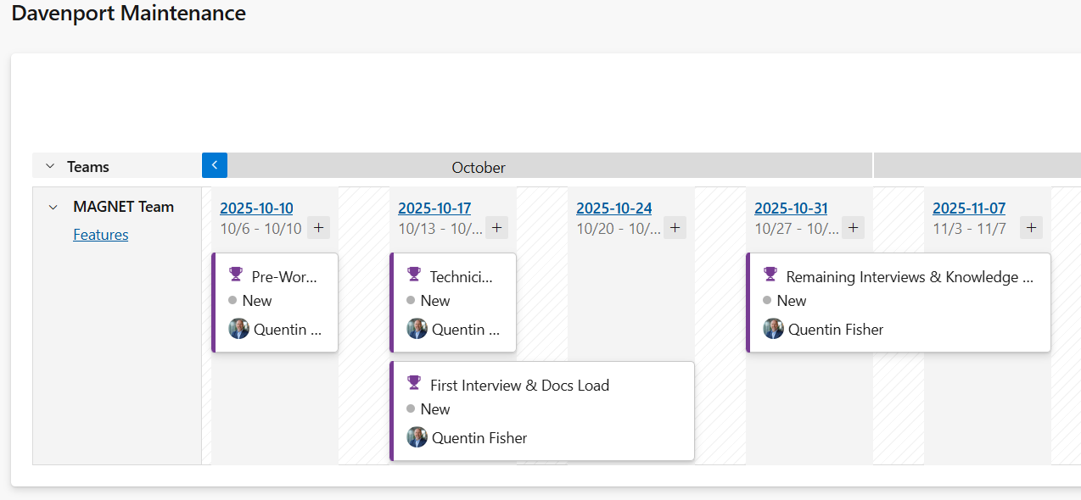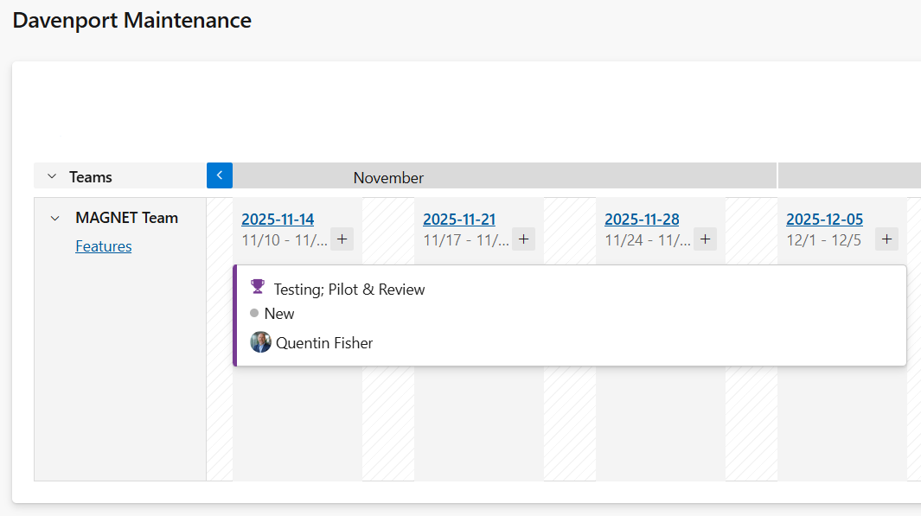
Story Points by Feature

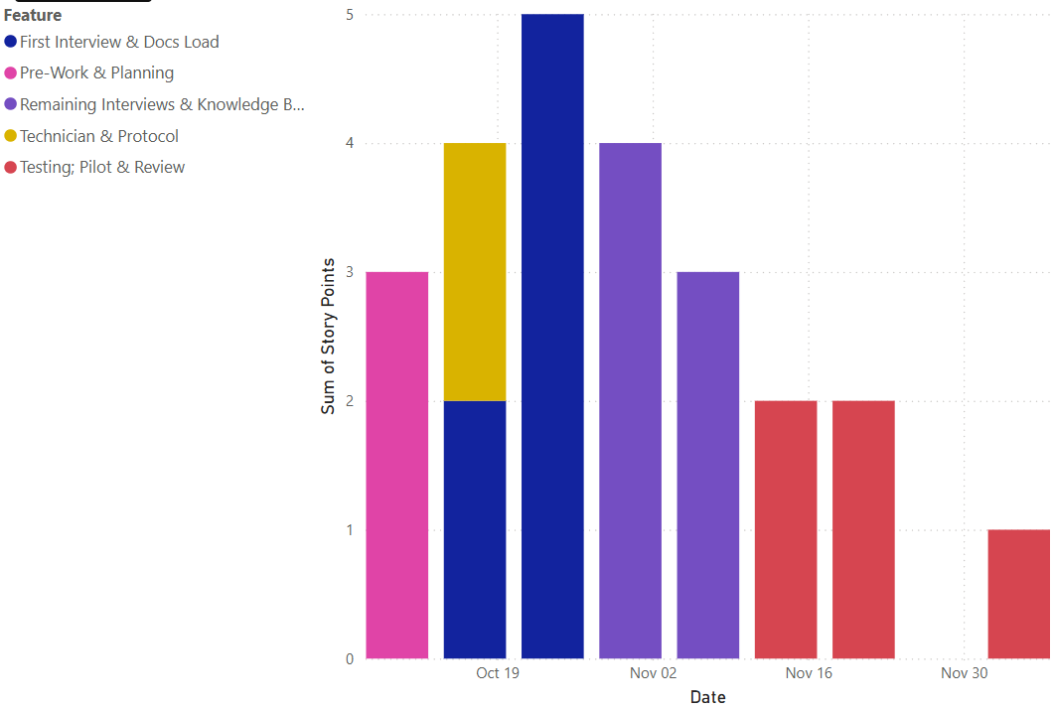

Story Points by Feature & Story by Week Ending Friday
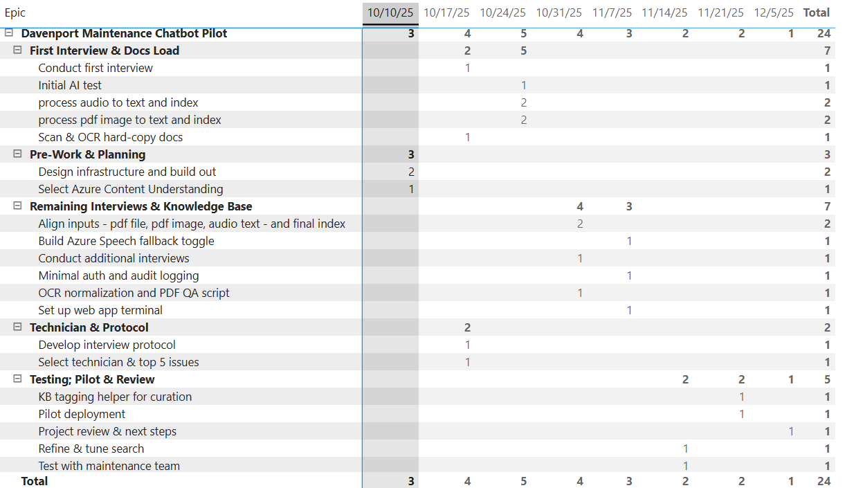

budget, fees and expenses

Scope of effort 24 points
Total Fee (Pilot): $36,000
$1500 / story point

Includes implementation, pilot support, and pilot report deliverables listed herein.
Azure Costs will be billed at actual
Additional Story Points, priced at $1500 per point.

invoicing & payment terms

Invoices will be submitted in advance of each phase or on a biweekly cadence during the pilot; Net 15 days.
Late payments may pause work until payment is received.

assumptions
We have outlined some key assumptions for this engagement:
- Shop-floor Wi-Fi is available for terminal connectivity.
- Shop-floor terminal with appropriate and current Windows environment provided by Gent Machine.
- Web application is acceptable for the pilot; Teams integration deferred to backlog.
- Text-first pilot: manuals; transcripts; parts lists (images/drawings Phase 2).
- Technician availability for interviews in Weeks 3–7.
- Azure Content Understanding is a new capability; buffer time allocated for potential issues.
- Gent will provide access to manuals and internal procedures required for ingestion.
- Basic Azure AD authentication is sufficient for pilot; advanced auth/RBAC is Phase 2.
- Aidan will host the pilot in its Azure environment; migration to MAGNET/Gent tenant can be scoped separately.
- Appropriate system and facility access will be granted for service implementation and operations.
- MAGNET will not solicit Aidan employees or contractors during and for 12 months after this engagement.
- Aidan is not responsible for activities performed by MAGNET, Gent, or third parties.

signatures
Acknowledgment and approval of this statement of work.

Aidan Health, Inc. MAGNET
DBA Aidan Systems

_____________________________ _________________________________
Quentin Fisher Michael O’Donnell
Print Name Print Name

Chief Executive Officer Chief Operating Officer
Title Title

Date Date

